**LOGISTIC RIGRESSION ASSIGNMENT**

**Que 1: -**

**Business Problem** = The predictor variables of interest are the amount of money spent on the campaign,

the amount of time spent campaigning negatively and whether or not the candidate is an incumbent.

* **Name of the File: -** Election.csv
* **Size of the File: -** 1 KB
* **Data: -** 10 Observation, 5 Variable

**Exploratory data Analysis** =

* **Outliers: -**  Outliers are No presents.
* **Missing Value: -** Data don’t have Missing Values
* **Normality: -** Data are not normal
* **Output:** - Binary

1. Measuring Percentage of Win an Election and Not win an election in output columns

**Win an Election** - 25%

**Not Win an Election**  – 85 %

**Model Building on Train Data =**

* **Summary: -**
* **AIC: -** 8.33
* **﻿Accuracy :-** 79%
* **﻿Sensitivity :-** nan
* **﻿Specificity: -** 0
* **No observation: -** -
* **﻿Df Residuals:** - -

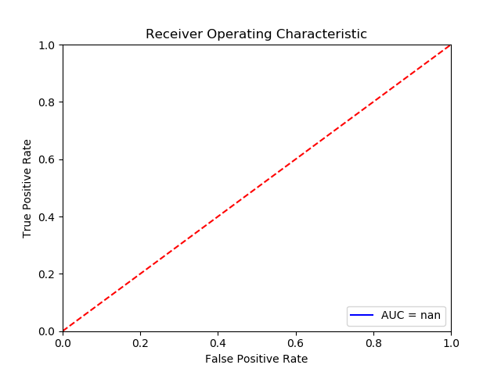

**Roc Curve**: - 75%

**Python code file**: - Affairs Assig-M9.py

**Packages used: -**

* ﻿pandas
* numpy
* scipy.stats
* matplotlib.pylab
* pylab
* statsmodels.formula.api
* seaborn as sns
* ﻿sklearn.model_selection import train_test_split
* ﻿statsmodels.api